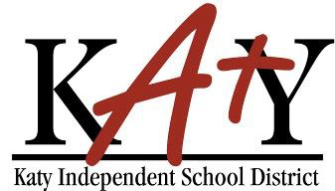

Katy ISD Photo/Video Permission Form

We (I) give permission to the Katy Independent School District, to take photos and/or video and to use said photos and/or video of my child(ren) as part of Theatre Arts Shortfilm Project.
I agree that Katy Independent School District may use such images for learning and instructional purposes and through Katy ISD communications tools, such as: Theatre Arts canvas pages.

Student(s) name:

Parent/Guardian name:
(Please print)

Parent/Guardian signature:
(Only one signature is required)

Date:

